Lab No. 11

Intel SIMD Technology

Lab Work
- Check the following dot product code;
int dot_product( short a[], short b[], int N)
{
int i, sum = 0;
for(i=0; i<N; i++)
{
sum += a[i] * b[i];
}
return sum;
}
Here each passed array is of size 1024 elements i.e. N = 1024;
  - Use loop unrolling technique to unroll this loop by a factor of 4.
Code:
#include <stdio.h>

int dot_product(short a[], short b[], int N)
{
int i, sum = 0;
for (i = 0; i <= N - 4; i += 4)
{
sum += a[i] * b[i];
sum += a[i + 1] * b[i + 1];
sum += a[i + 2] * b[i + 2];
sum += a[i + 3] * b[i + 3];
}
for (; i < N; i++)
{
sum += a[i] * b[i];
}

return sum;
}

int main()
{
short a[1024], b[1024];
int i;

// Example initialization
for (i = 0; i < 1024; i++)
{
a[i] = i % 10;
b[i] = (i + 1) % 10;
}

int result = dot_product(a, b, 1024);
printf("Dot product = %d\n", result);

return 0;
}
Output:
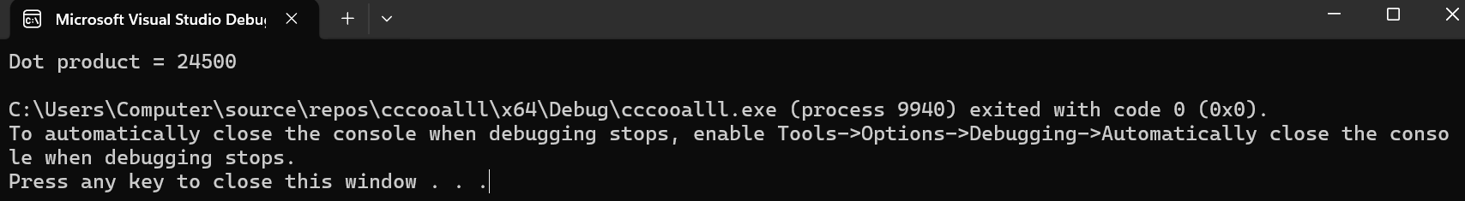
Registers:
  - Write the inline assembly code for the loop unrolled code using MMX instruction set. The inline assembly template will look like as follows;
Code:
#include <stdio.h>
double dotProductMMX(double* a, double* b, int n)
{
double result = 0.0;

__asm {

pxor mm0, mm0; mm0 = 0 (accumulator)

mov esi, a
mov edi, b
mov ecx, n

shr ecx, 1; loop unrolling(2 elements at a time)

L1:
movq mm1, qword ptr[esi]; load 2 doubles from a
movq mm2, qword ptr[edi]; load 2 doubles from b

pmuludq mm1, mm2; multiply(packed)

paddq mm0, mm1; accumulate result

add esi, 16
add edi, 16

loop L1

movq qword ptr result, mm0; store result

emms; exit MMX mode
}

return result;
}

int main()
{
double a[8] = { 10,20,30,40,50,60,70,80 };
double b[8] = { 100,200,300,400,500,600,700,-800 };

double res = dotProductMMX(a, b, 8);

printf("MMX Dot Product = %lf\n", res);

return 0;
}
Output:
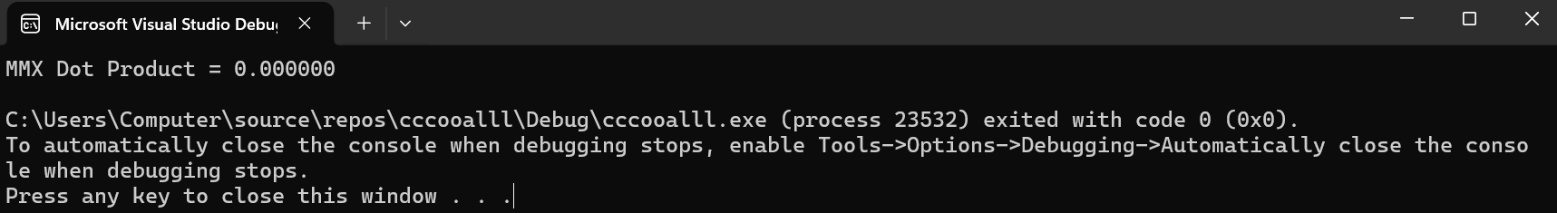
Registers:

Checked By: Date:

